Project Name - Cloud-Based File Storage System

Created AWS Account and Created S3 Bucket – cloud-drive-kavya-2026
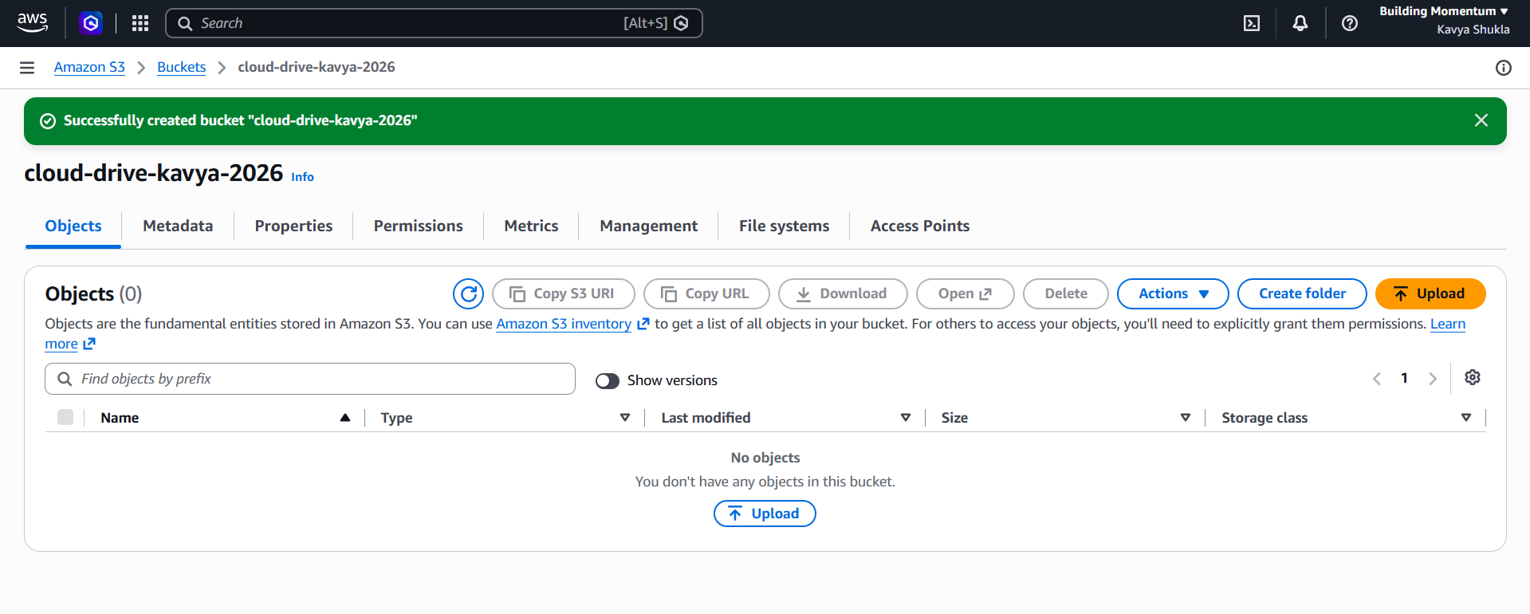
Creating IAM user(Security Guard) to get Keys. We did NOT use root account. We created a new user cloud-drive-user.We gave him only S3 permission (not full AWS). This is what companies do for security.

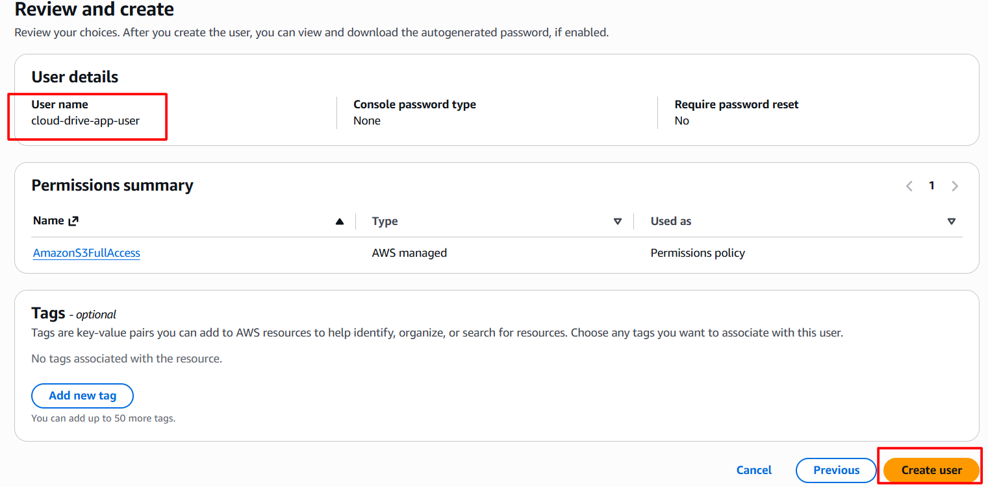
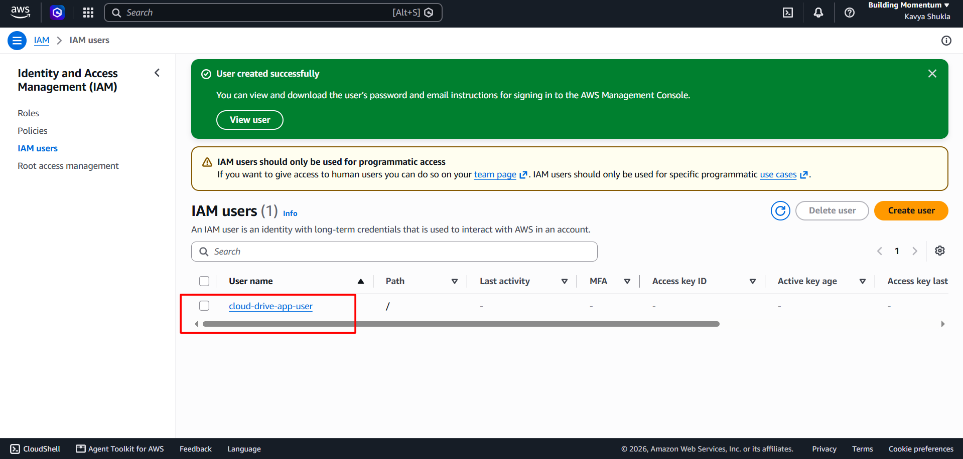
Access key Retrieved, We got Access Key and Secret Key - this is like ID card for your app to talk to AWS.

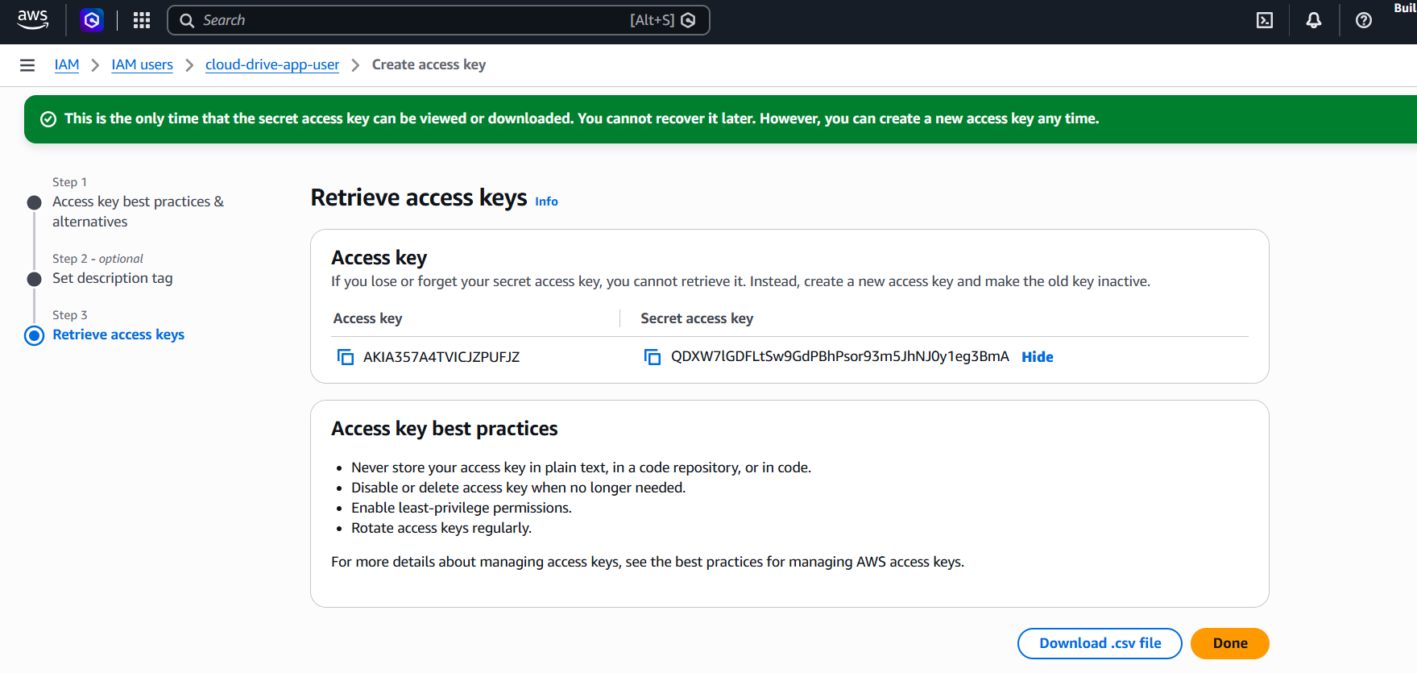

Bucket Versioning - Enabled

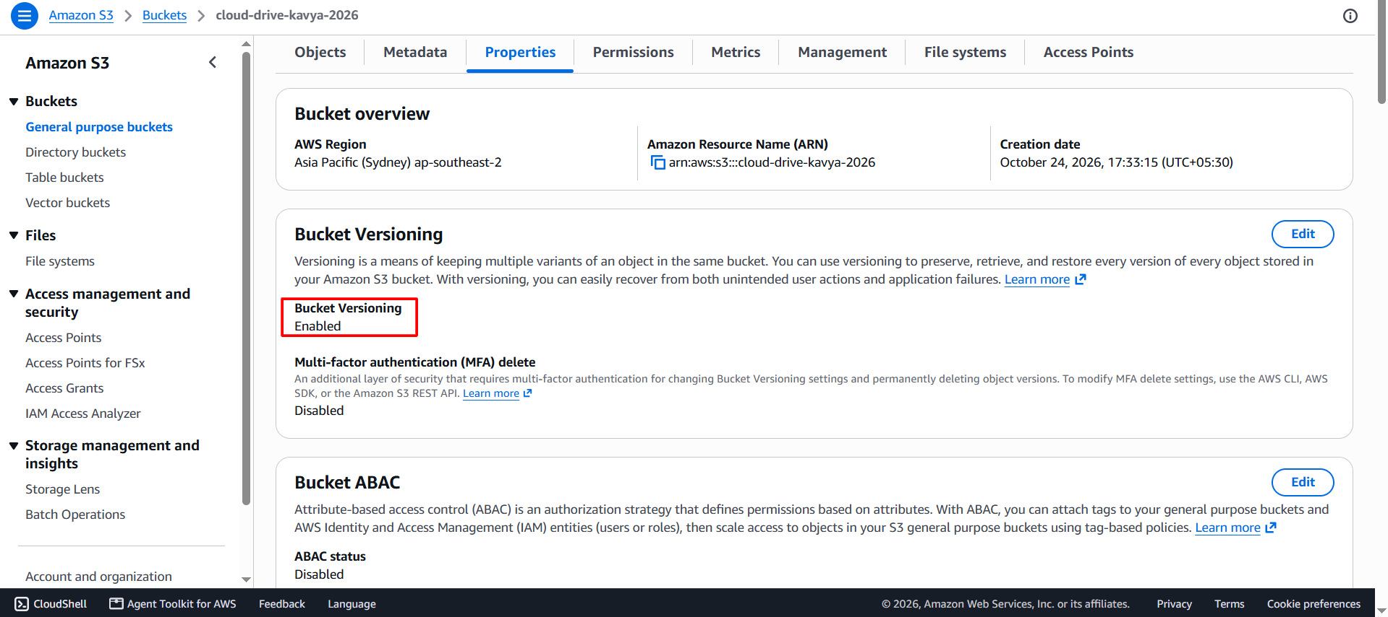

Created Google cloud project and Configure Consent Screen.
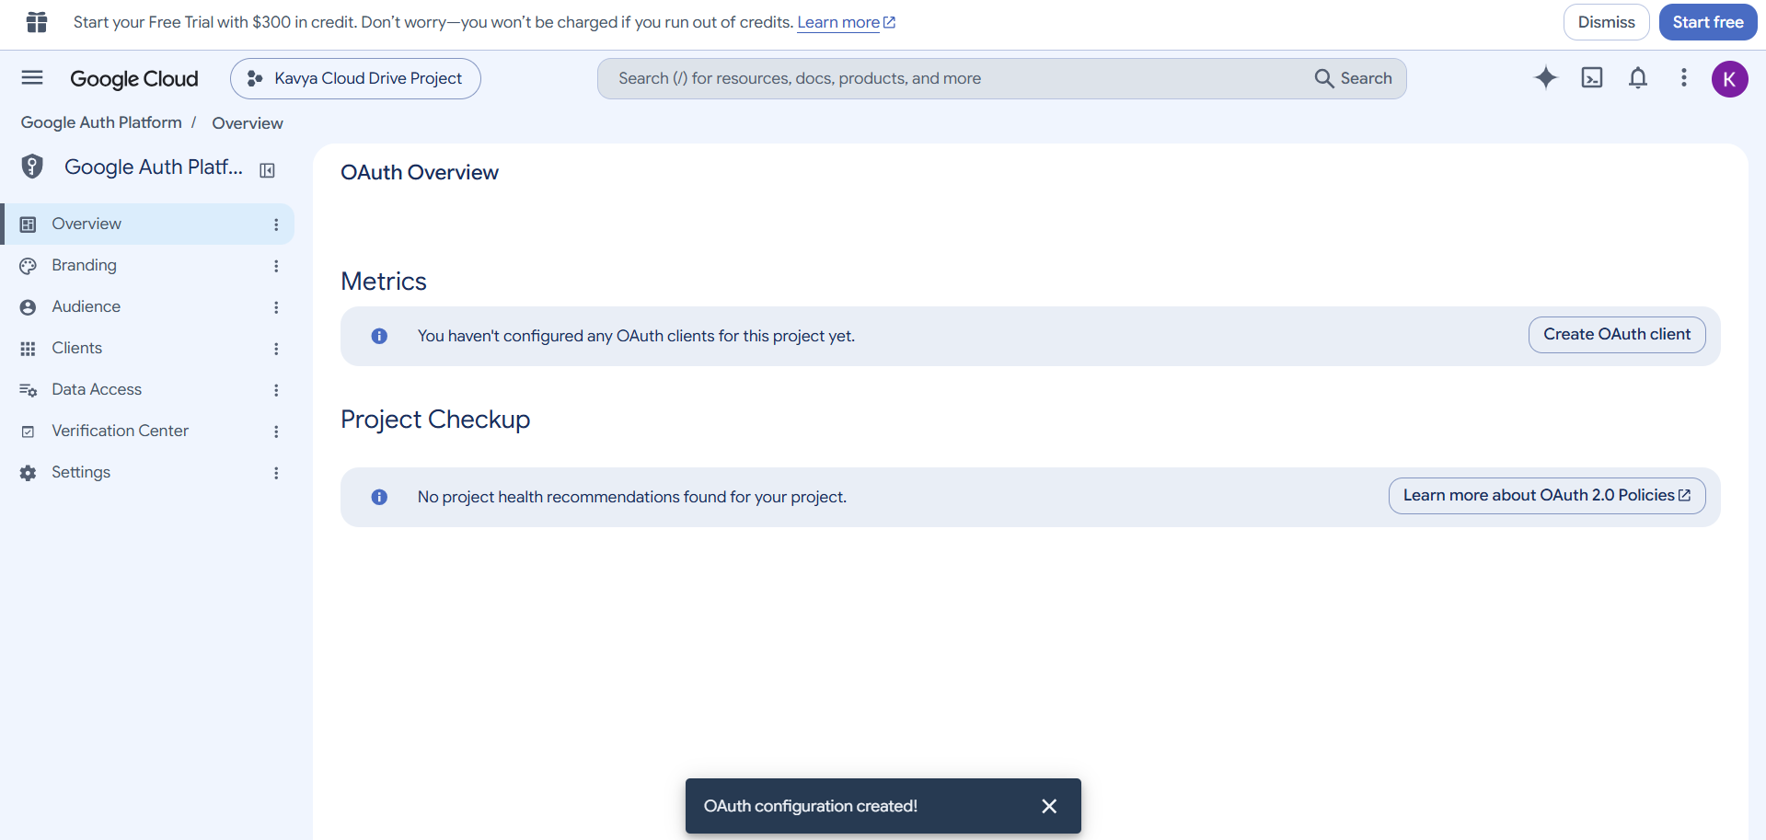

Created OAuth Credentials
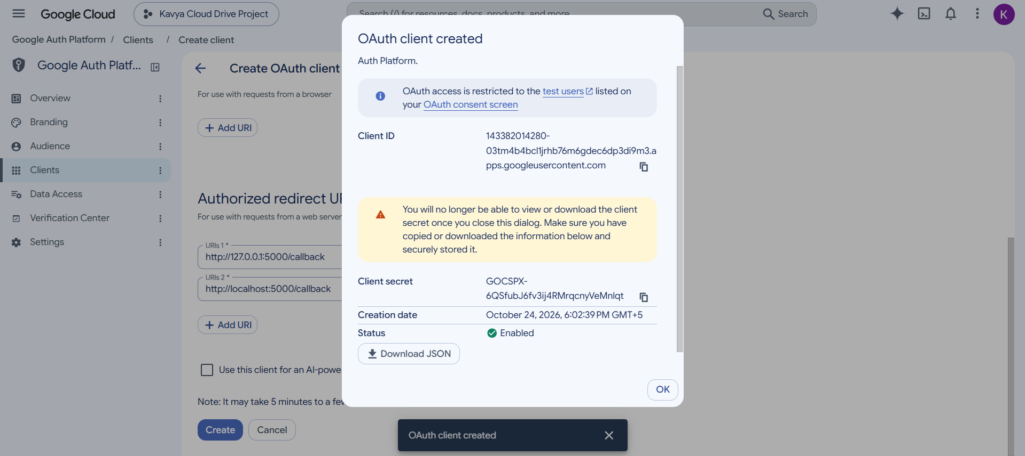
Created a folder on Desktop named as cloud-drive and created file .env and paste all 5 values .
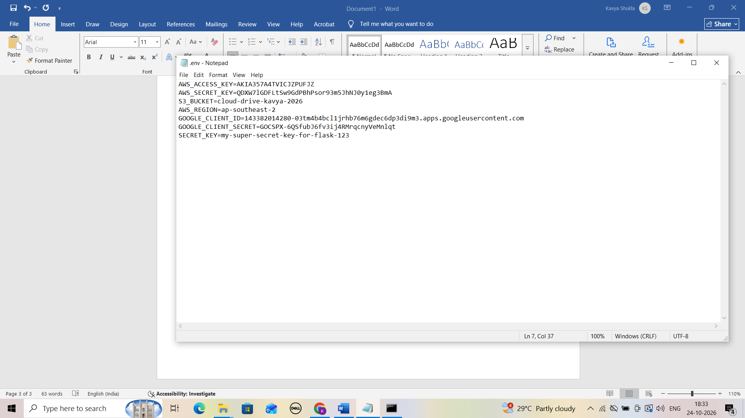

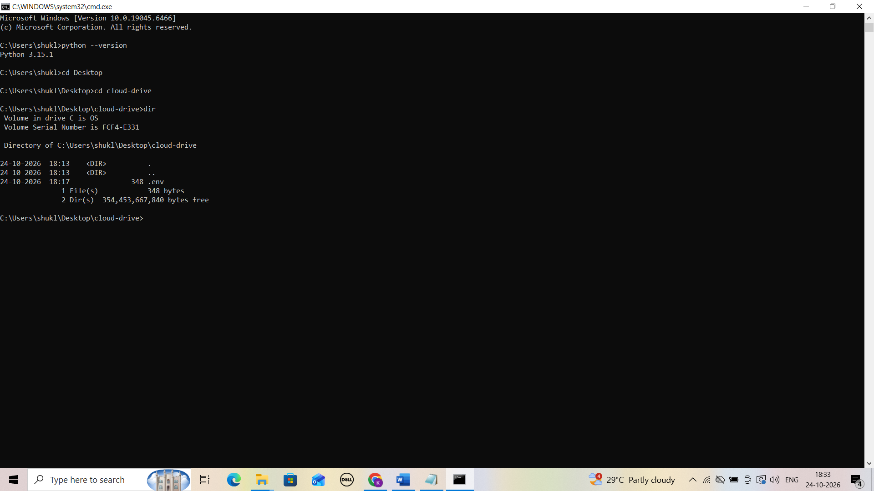

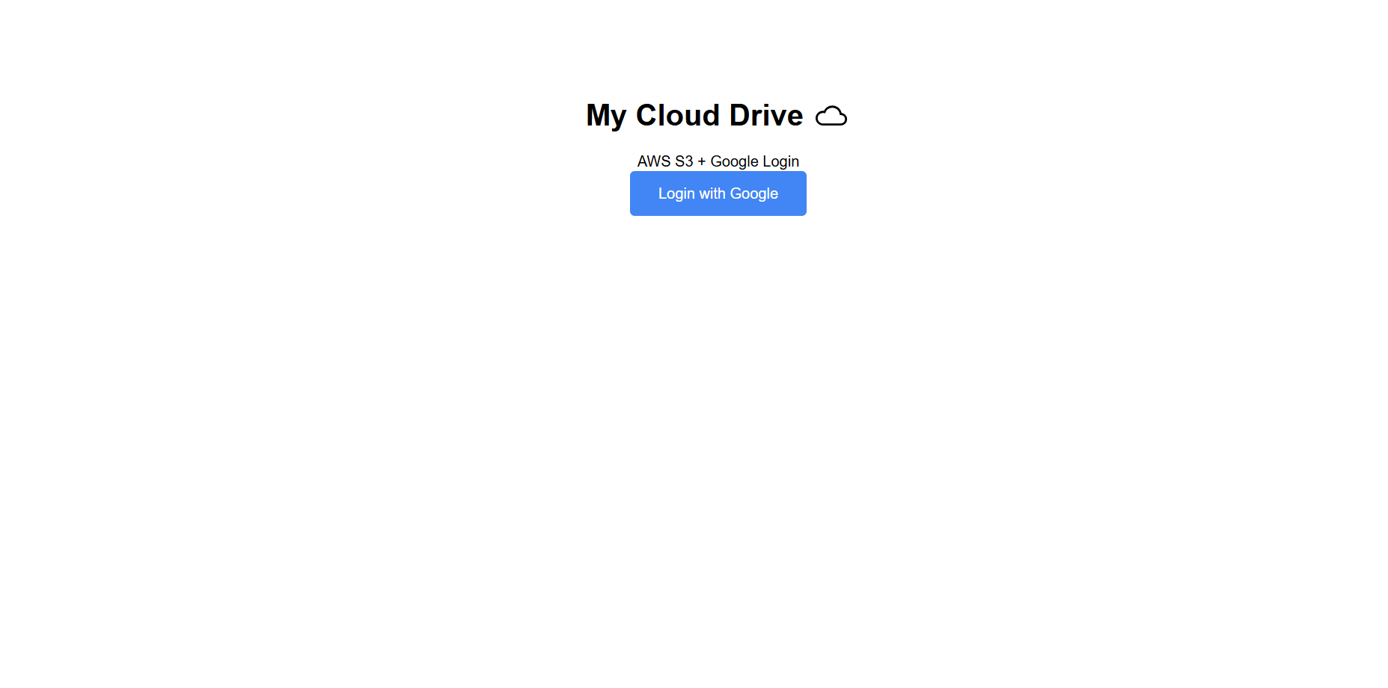
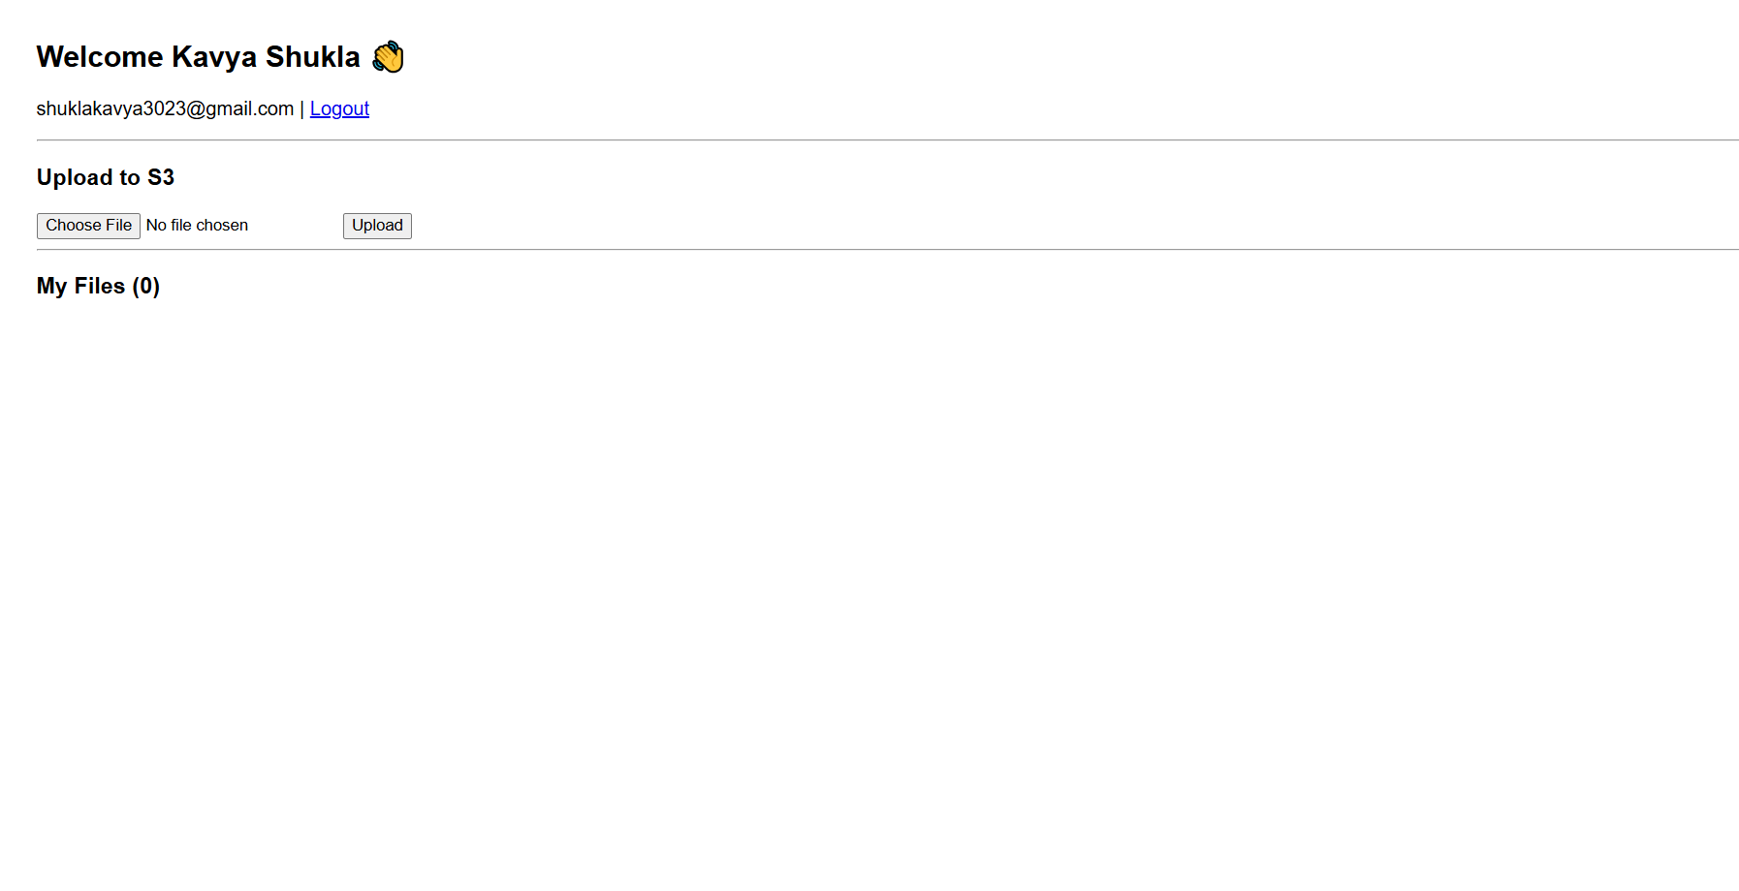
Clicked on choose file and uploaded a file from a system
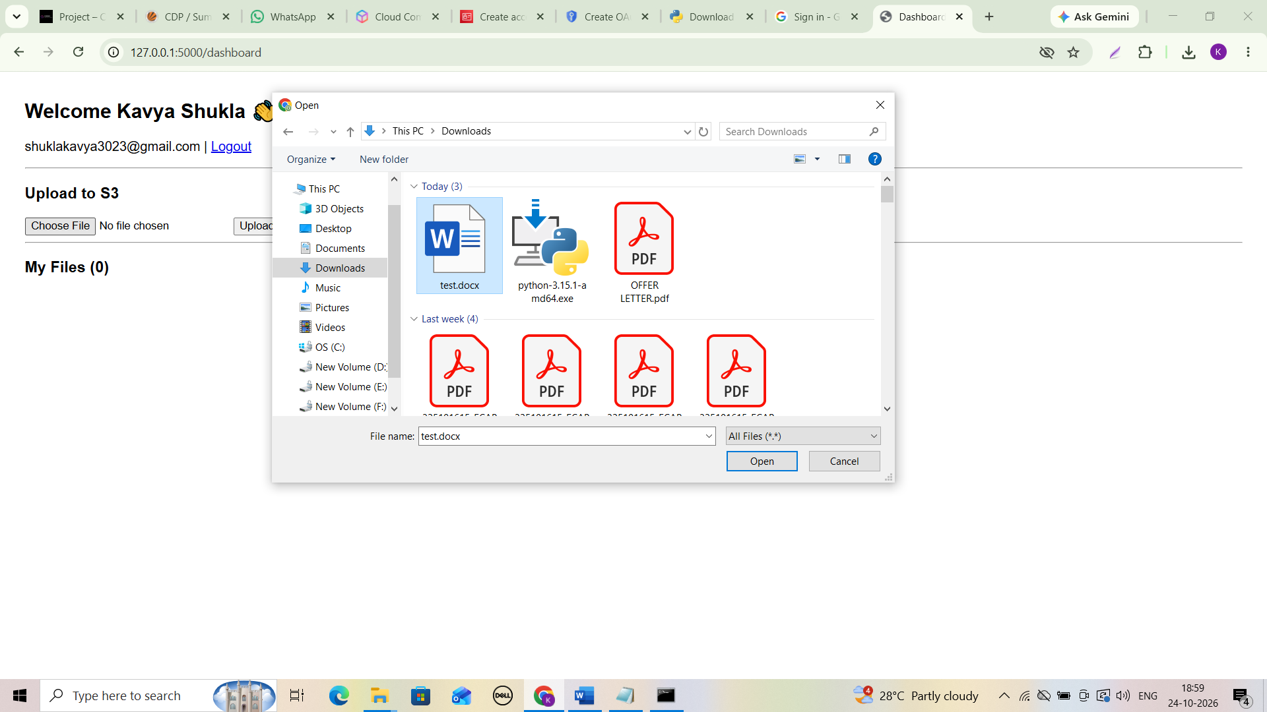

File added and uploaded successfully.
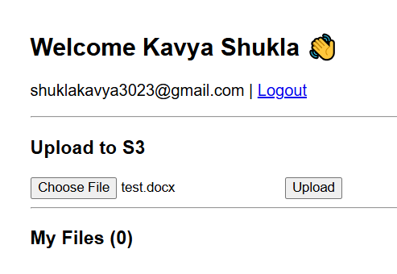
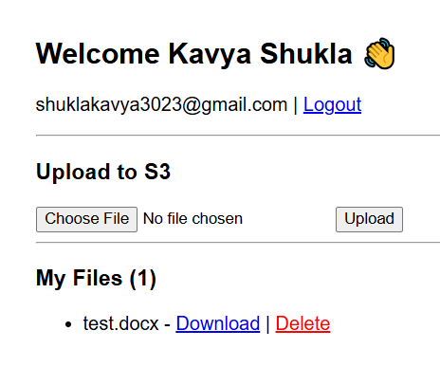

Open AWS S3 Opened cloud-drive-kavya-2026(my bucket). Same file(test.docx) added successfully .
